**Experiment No:** 3

**Experiment Name:** Interconnection of LAN.

**Theory**: A local area network is used to connect an organization's computers to one another; nevertheless, a single organization often includes several local area networks, so it is sometimes necessary to link the networks together. In such a case, specialized equipment is needed.

If it's just two networks of the same type, all that is needed is to send the data frames from one to the other. Otherwise, that is, when the networks use different protocols, you need to convert the protocol before sending the frames. For this reason, the equipment that must be installed varies depending on the configuration at hand.

## Connection equipment:-

The primary hardware set up in local area networks is:

* [Repeaters](http://ccm.net/contents/repeteurs.php3), used to refresh a signal
* [Hubs](http://ccm.net/contents/concentrateurs.php3), used for connecting multiple hosts together
* [Bridges](http://ccm.net/contents/ponts.php3), used for linking local area networks of the same type
* [Switches](http://ccm.net/contents/commutateurs.php3), used for linking various elements while they divide up the network
* [Gateways](http://ccm.net/contents/gateway.php3), used for linking local area networks of different types
* [Routers](http://ccm.net/contents/routeurs.php3), used for linking numerous local area networks so as to allow data to travel optimally between networks
* [Bridge/routers](http://ccm.net/contents/brouteurs.php3), which join the features of a router and a bridge

**Working Procedure**: At first, open a Cisco software and then set up IP address.

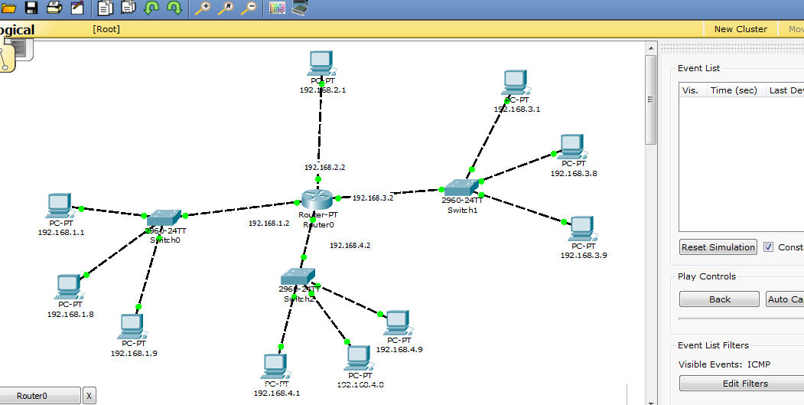

After, send a message from one pc to another pc.

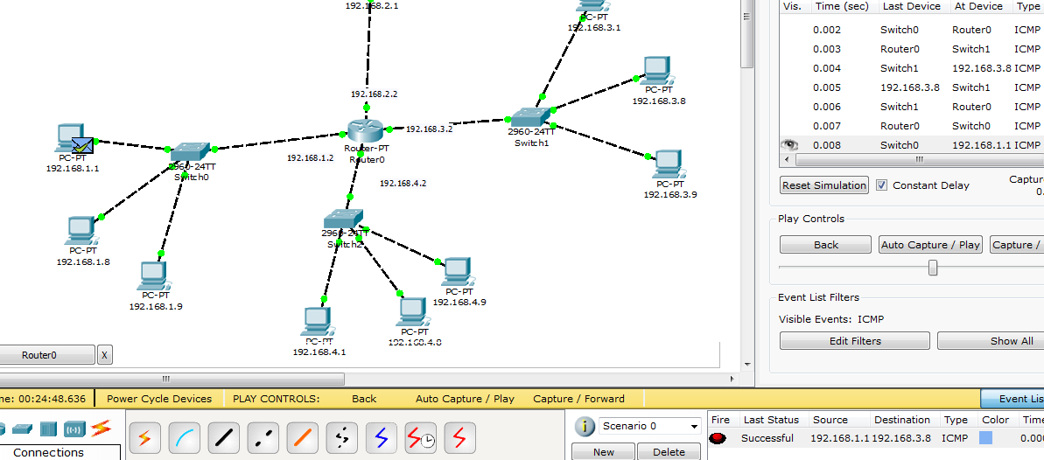

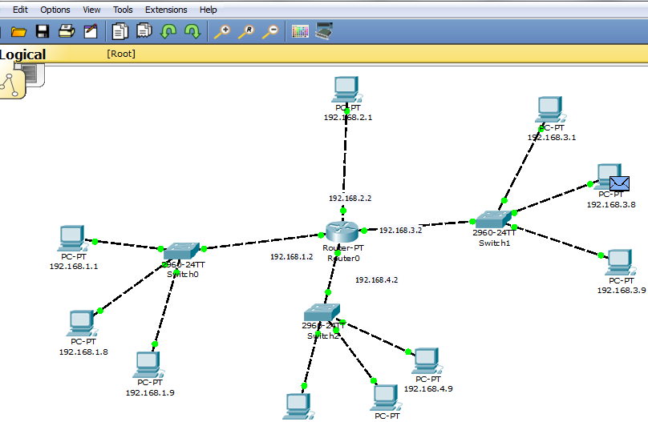

Then, IP configuration for every pc.

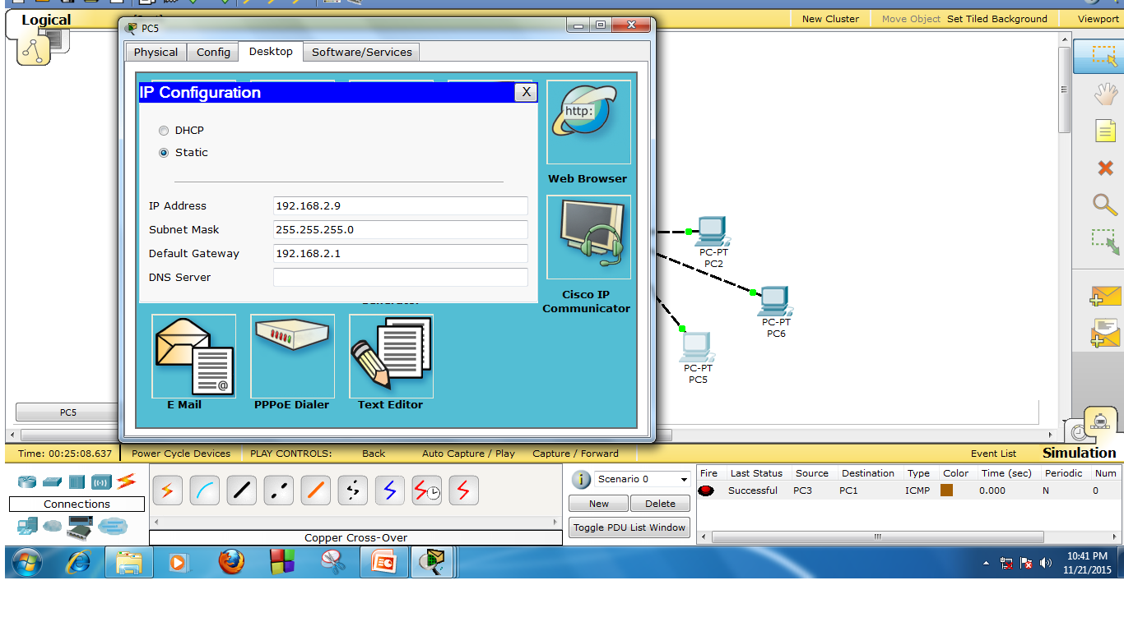

Then, IOS command line interface for each router.

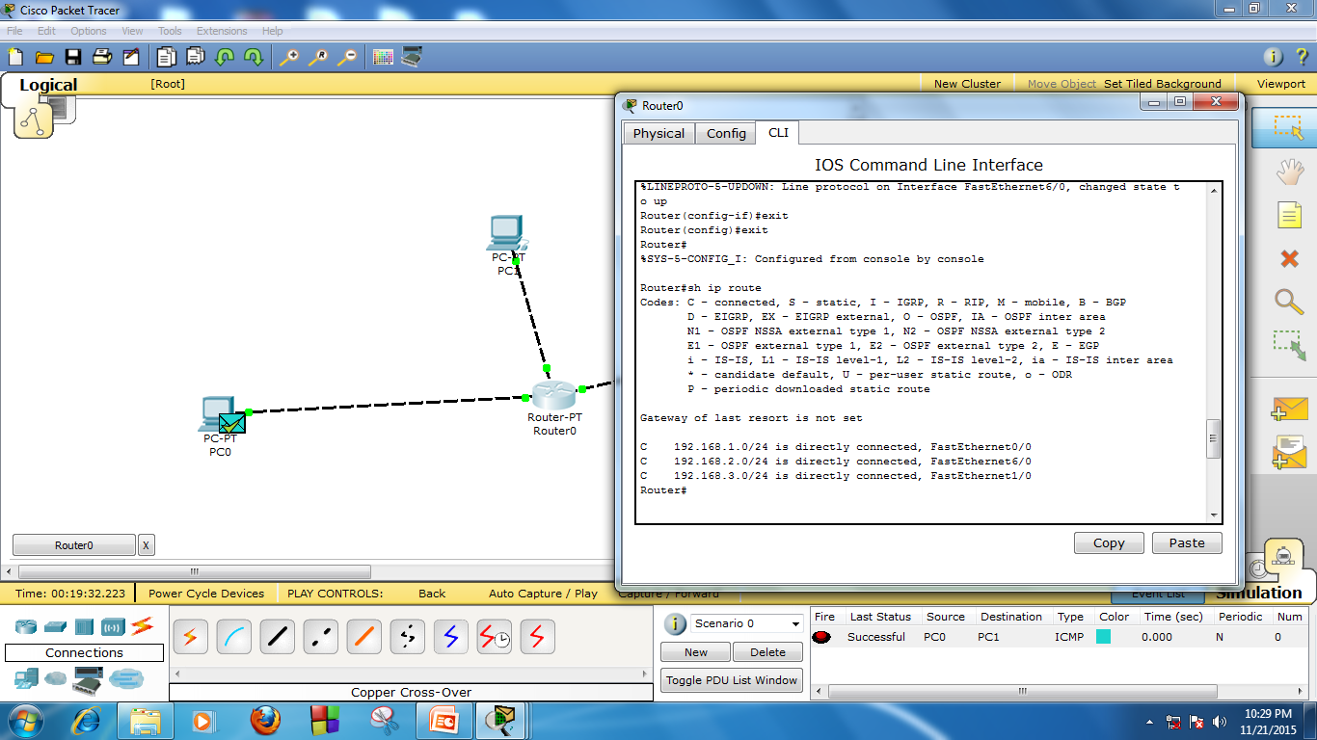

**Conclusion:** Many interconnection devices are required in a modern network, from the interface that allows a single computer to communicate with other computers via a LAN cable or a telephone line, to the large and complex switching devices that interconnect two or more entire networks.